Tail dependence: AUDUSD and USDCHF
Method 19 / daily log returns / alpha=0.05 / Alpari D1 full available history

Study setup
Logical pair: AUDUSD , USDCHF
Broker symbols: AUDUSD_i , USDCHF_i
Snapshot: 2026-11-03_majors_alpari_D1
Timeframe: D1
Matched return window: 1999-01-05 to 2026-11-02 (UTC bar dates)
Matched return count n: 7200
Dropped unfinished last bar dated 2026-11-03 UTC after a tick-volume check against the prior complete day.
Uniforms: ranks/(n+1); alpha=0.05
Complete matched rows (Excel): AUDUSD-USDCHF_Tail_D1.xlsx
Complete matched rows (HTML table): AUDUSD-USDCHF_Tail_D1_data.html

Method carried forward
Tail dependence counts how often both legs sit in an extreme uniform tail together. Matched daily log returns of close, ln(close_t / close_t-1), become u_i = rank(x_i)/(n+1) and v_i = rank(y_i)/(n+1). At alpha=0.05, lower L_hat = (# u<=alpha and v<=alpha) / (# conditioning leg <= alpha); upper uses >= 1-alpha. Both conditioning directions are reported with numerator and denominator counts. Quotes are not inverted. L_hat(0.05) is a finite-sample frequency, not the asymptotic lambda. Same-sample Pearson r is a side check. This is not causation and not a trading signal.

Results
tail | cond | L_hat | num | denom
lower | USDCHF | 0.036111 | 13 | 360
lower | AUDUSD | 0.036111 | 13 | 360
upper | USDCHF | 0.033333 | 12 | 360
upper | AUDUSD | 0.033333 | 12 | 360
Pearson r on returns: -0.380878

Conclusion
Over 7200 matched daily rows for AUDUSD and USDCHF at alpha=0.05, lower L_hat conditioning on USDCHF is 0.0361 (13/360); conditioning on AUDUSD is 0.0361. Upper L_hat conditioning on USDCHF is 0.0333; on AUDUSD is 0.0333. Pearson r = -0.3809. These are finite-sample frequencies, not asymptotic lambda and not a trading signal.

Charts
Daily closes

Daily log returns

Uniforms with alpha lines
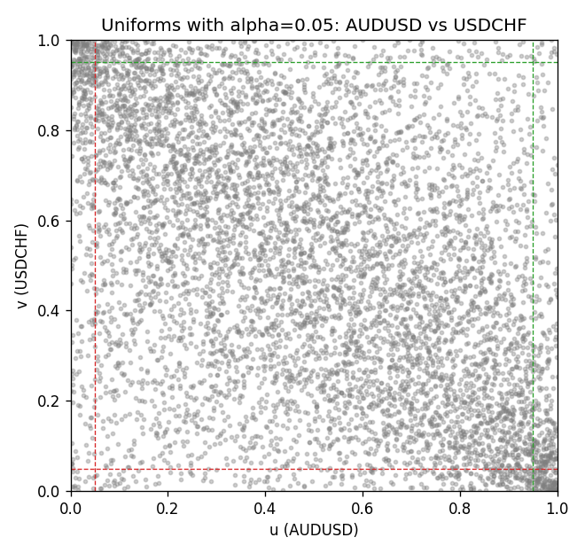

Data report
Every matched row is stored in the sibling Excel workbook named AUDUSD-USDCHF_Tail_D1.xlsx, including u and v. Embedding all rows as a Word table is impractical; this file holds column summaries and the first and last 15 matched rows.
Columns: time, AUDUSD_open, USDCHF_open, AUDUSD_high, USDCHF_high, AUDUSD_low, USDCHF_low, AUDUSD_close, USDCHF_close, AUDUSD_tick_volume, USDCHF_tick_volume, AUDUSD_spread, USDCHF_spread, AUDUSD_real_volume, USDCHF_real_volume, AUDUSD_log_return, USDCHF_log_return, u, v
Column summaries (matched calculation rows)
column | count | mean | std | min | 25% | 50% | 75% | max
AUDUSD_open | 7200 | 0.7519587 | 0.13528421 | 0.4785 | 0.6610975 | 0.731415 | 0.8091275 | 1.10284
USDCHF_open | 7200 | 1.0982244 | 0.25258622 | 0.72022 | 0.920675 | 0.990175 | 1.238625 | 1.8219
AUDUSD_high | 7200 | 0.75601148 | 0.13584385 | 0.4878 | 0.6647 | 0.734785 | 0.8152525 | 1.10795
USDCHF_high | 7200 | 1.1035234 | 0.25433538 | 0.73305 | 0.9249475 | 0.99377 | 1.2436 | 1.8313
AUDUSD_low | 7200 | 0.74790307 | 0.1345988 | 0.4775 | 0.65778 | 0.727495 | 0.804225 | 1.0975
USDCHF_low | 7200 | 1.0930985 | 0.25099871 | 0.08565 | 0.917415 | 0.98668 | 1.232725 | 1.8121
AUDUSD_close | 7200 | 0.75201172 | 0.13526687 | 0.4786 | 0.6612 | 0.731695 | 0.8091975 | 1.10169
USDCHF_close | 7200 | 1.0982149 | 0.25248642 | 0.72025 | 0.92097 | 0.990145 | 1.238625 | 1.8217
AUDUSD_tick_volume | 7200 | 77358.386 | 138142.18 | 109 | 5440 | 43334.5 | 71332.25 | 1234623
USDCHF_tick_volume | 7200 | 74199.562 | 113414.45 | 350 | 12776 | 40195 | 70261.25 | 858589
AUDUSD_spread | 7200 | 30.817222 | 16.887144 | 0 | 13 | 30 | 50 | 50
USDCHF_spread | 7200 | 26.104306 | 24.710129 | 0 | 5 | 16 | 50 | 100
AUDUSD_real_volume | 7200 | 5.2428187e+09 | 1.2538918e+11 | 0 | 0 | 0 | 0 | 3.811512e+12
USDCHF_real_volume | 7200 | 2.3239785e+10 | 8.9047261e+10 | 0 | 0 | 0 | 0 | 1.9331921e+12
AUDUSD_log_return | 7200 | 2.837e-05 | 0.00754598 | -0.08602525 | -0.00385535 | 0.0002835 | 0.00415437 | 0.0806166
USDCHF_log_return | 7200 | -7.168e-05 | 0.00659376 | -0.19545699 | -0.00336083 | 8.057e-05 | 0.00331954 | 0.09051364
u | 7200 | 0.5 | 0.28865507 | 0.00013887 | 0.25006943 | 0.5 | 0.74993057 | 0.99986113
v | 7200 | 0.5 | 0.28865508 | 0.00013887 | 0.25006943 | 0.5 | 0.74993057 | 0.99986113
First 15 matched rows (selected columns)
time | AUDUSD_log_return | USDCHF_log_return | u | v
1999-01-05 | -0.00080418179 | 0.0039424743 | 0.4307735 | 0.78364116
1999-01-06 | 0.011836351 | 0.013605652 | 0.95847799 | 0.98375226
1999-01-07 | 0.0088650256 | -0.0093883841 | 0.91681711 | 0.058741841
1999-01-08 | 0.00031515916 | 0.011040268 | 0.50215248 | 0.96694903
1999-01-11 | 0.0072213815 | 0.0052963193 | 0.87751701 | 0.84488266
1999-01-12 | -0.0048608485 | -0.0098275602 | 0.20538814 | 0.052631579
1999-01-13 | -0.0078902098 | -0.018259701 | 0.11095681 | 0.0058325233
1999-01-14 | -0.002696916 | -0.0024256692 | 0.31148452 | 0.30509651
1999-01-15 | 0.007123101 | 0.01794228 | 0.87348979 | 0.99486182
1999-01-18 | 0.00094592471 | -0.0031856384 | 0.54631301 | 0.25940842
1999-01-19 | 0.0072225153 | -7.2518946e-05 | 0.87765588 | 0.48632134
1999-01-20 | 0.0012507819 | 0.0072259871 | 0.5664491 | 0.90779058
1999-01-21 | 0.00078094498 | -0.0038232689 | 0.53506457 | 0.2270518
1999-01-22 | -0.012252745 | -0.0001445609 | 0.044021664 | 0.47993334
1999-01-25 | -0.0039591468 | 0.0024546976 | 0.24482711 | 0.69115401
Last 15 matched rows (selected columns)
time | AUDUSD_log_return | USDCHF_log_return | u | v
2026-10-13 | 0.0035007712 | -0.0024955621 | 0.71240106 | 0.30023608
2026-10-14 | -0.0015193215 | 0.0029388325 | 0.3818914 | 0.72503819
2026-10-15 | -0.0075447063 | -0.0097855323 | 0.11748368 | 0.053603666
2026-10-16 | 0.0033906408 | -0.0036230826 | 0.70656853 | 0.23843911
2026-10-19 | 0.0050859986 | 0.0036351779 | 0.79502847 | 0.7679489
2026-10-20 | 0.0034620426 | -0.0026281224 | 0.71031801 | 0.29218164
2026-10-21 | 0.0036066384 | -0.00040027413 | 0.71920567 | 0.45604777
2026-10-22 | -0.0012672558 | -0.0048036381 | 0.39980558 | 0.18400222
2026-10-23 | 0.0023765656 | 0.005652514 | 0.63796695 | 0.86015831
2026-10-26 | -0.0032032829 | 0.0018407959 | 0.28259964 | 0.64338286
2026-10-27 | 0.0016669876 | 0.0026100526 | 0.59075128 | 0.70087488
2026-10-28 | 0.0040915541 | -0.0010142111 | 0.74656298 | 0.40813776
2026-10-29 | -0.0040915541 | -0.0048680164 | 0.23927232 | 0.18094709
2026-10-30 | 0.0010102376 | 0.00071594559 | 0.54950701 | 0.55395084
2026-11-02 | -0.0049184984 | -0.0071459744 | 0.20274962 | 0.10304124

